Structured Training Program: Advance C Programming
Week 1 – Refresh on C, Pointers and Memory Management
Topic 1: Structures
C program that represents a calendar for a week. Every day has:
- dayName (eg., “Monday”)
- tasks (array of string with maximum 3 tasks per day)
Note:
- Define appropriate structures.
- Allow the user to input taska for any day.
- Display all taks grouped by the day.
Code:
#include <stdio.h>
#include <stdlib.h>
#include <string.h>

typedef struct Day {
char dayName [10];
char tasks [3][100];
} Day;

int main() {
Day days[7];
for (int i = 0; i < 7; i++) {
days[i].dayName[0] = '\0';
for (int j = 0; j < 3; j++) {
days[i].tasks[j][0] = '\0';
}
}
while(1) {
char input[10];
printf("Enter a day of the week (or 'exit' to quit): ");
fgets(input, sizeof(input), stdin);
input[strcspn(input, "\n")] = '\0';
if (strcmp(input, "exit") == 0) {
break;
}
int index = -1;
if (strcmp(input, "Monday") == 0) index = 0;
else if (strcmp(input, "Tuesday") == 0) index = 1;
else if (strcmp(input, "Wednesday") == 0) index = 2;
else if (strcmp(input, "Thursday") == 0) index = 3;
else if (strcmp(input, "Friday") == 0) index = 4;
else if (strcmp(input, "Saturday") == 0) index = 5;
else if (strcmp(input, "Sunday") == 0) index = 6;
if (index != -1) {
strcpy(days[index].dayName, input);
taskInput:
printf("Enter the number of tasks for %s: ", input);
int numTasks;
scanf("%d%*c", &numTasks);

if(numTasks > 3){
fprintf(stderr, "No. of tasks is greater than 3, give tasks less than 3\n");
goto taskInput;
}
while(numTasks--) {
char task[100];
printf("Enter a task: ");
fgets(task, sizeof(task), stdin);
task[strcspn(task, "\n")] = '\0';
if(strlen(task) >= 100){
fprintf(stderr, "Task name is too long, give task name less than 100 characters\n");
numTasks++;
continue;
}
strcpy(days[index].tasks[numTasks], task);
}
}
}
printf("\nWeekly Schedule:\n");
for (int i = 0; i < 7; i++) {
if (strlen(days[i].dayName) > 0) {
printf("%s:\n", days[i].dayName);
for (int j = 0; j < 3; j++) {
if (strlen(days[i].tasks[j]) > 0) {
printf(" - %s\n", days[i].tasks[j]);
}
}
}
}

}

Output:
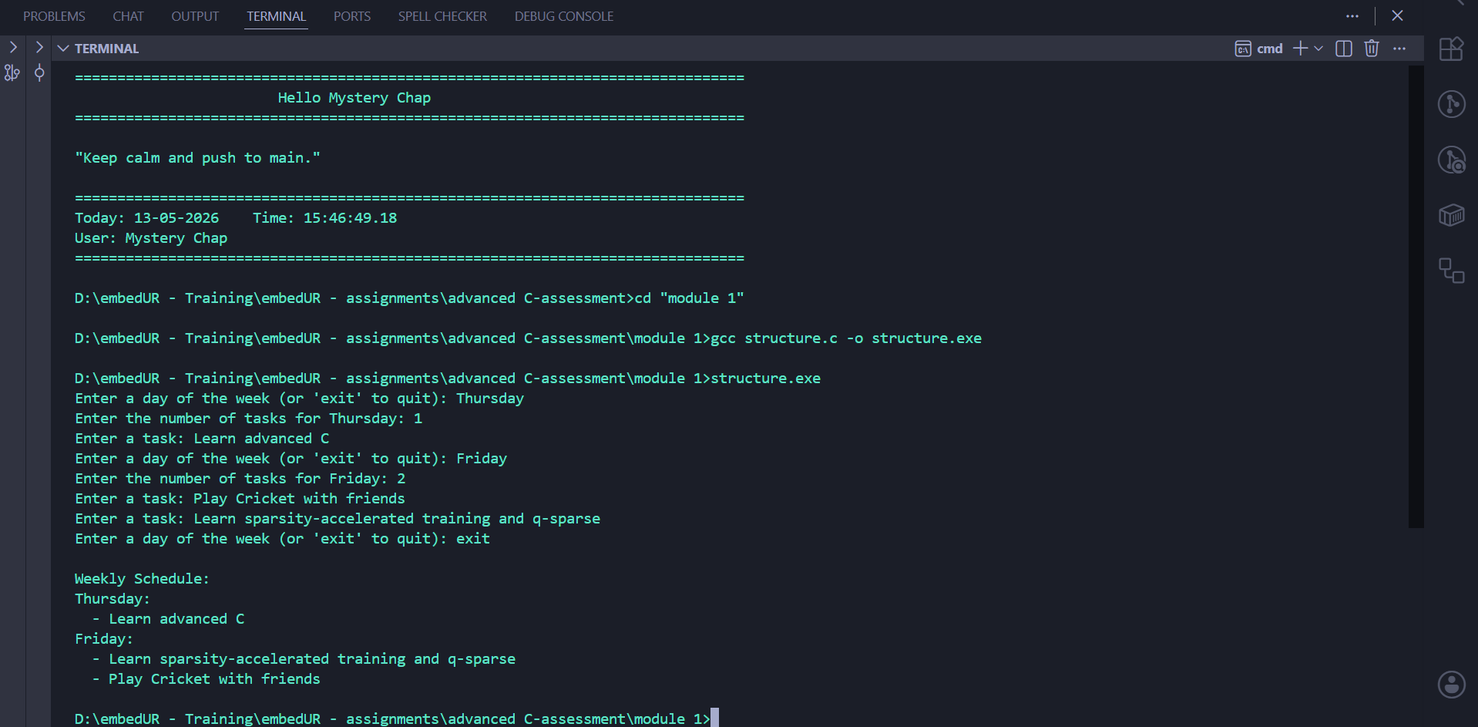

Topic 2: Pointers
Write a function in C that takes a pointer to an integer array and its size, and then rearranges the array in-place such that all even numbers arrear before odd numbers, preserving the original relative order using only pointer arithmetics (no indexing with [])
Code:
#include <stdio.h>
#include <stdlib.h>

void rearrangeArray(int* arr, int size) {
for (int i = 1; i < size; i++) {
if (*(arr + i) % 2 == 0) {
int key = *(arr + i);
int j = i - 1;
while (j >= 0 && *(arr + j) % 2 != 0) {
*(arr + j + 1) = *(arr + j);
j--;
}
*(arr + j + 1) = key;
}
}
}
int main() {
int size;
printf("Enter the size of the array: ");
scanf("%d", &size);
int* arr = (int*)malloc(size * sizeof(int));

printf("Enter %d integers:\n", size);
for (int i = 0; i < size; i++) {
printf("Element %d: ", i + 1);
scanf("%d", arr + i);
}

rearrangeArray(arr, size);

printf("Rearranged array: ");
for (int i = 0; i < size; i++) {
printf("%d ", *(arr + i));
}
printf("\n");
free(arr);

return 0;
}

Output:
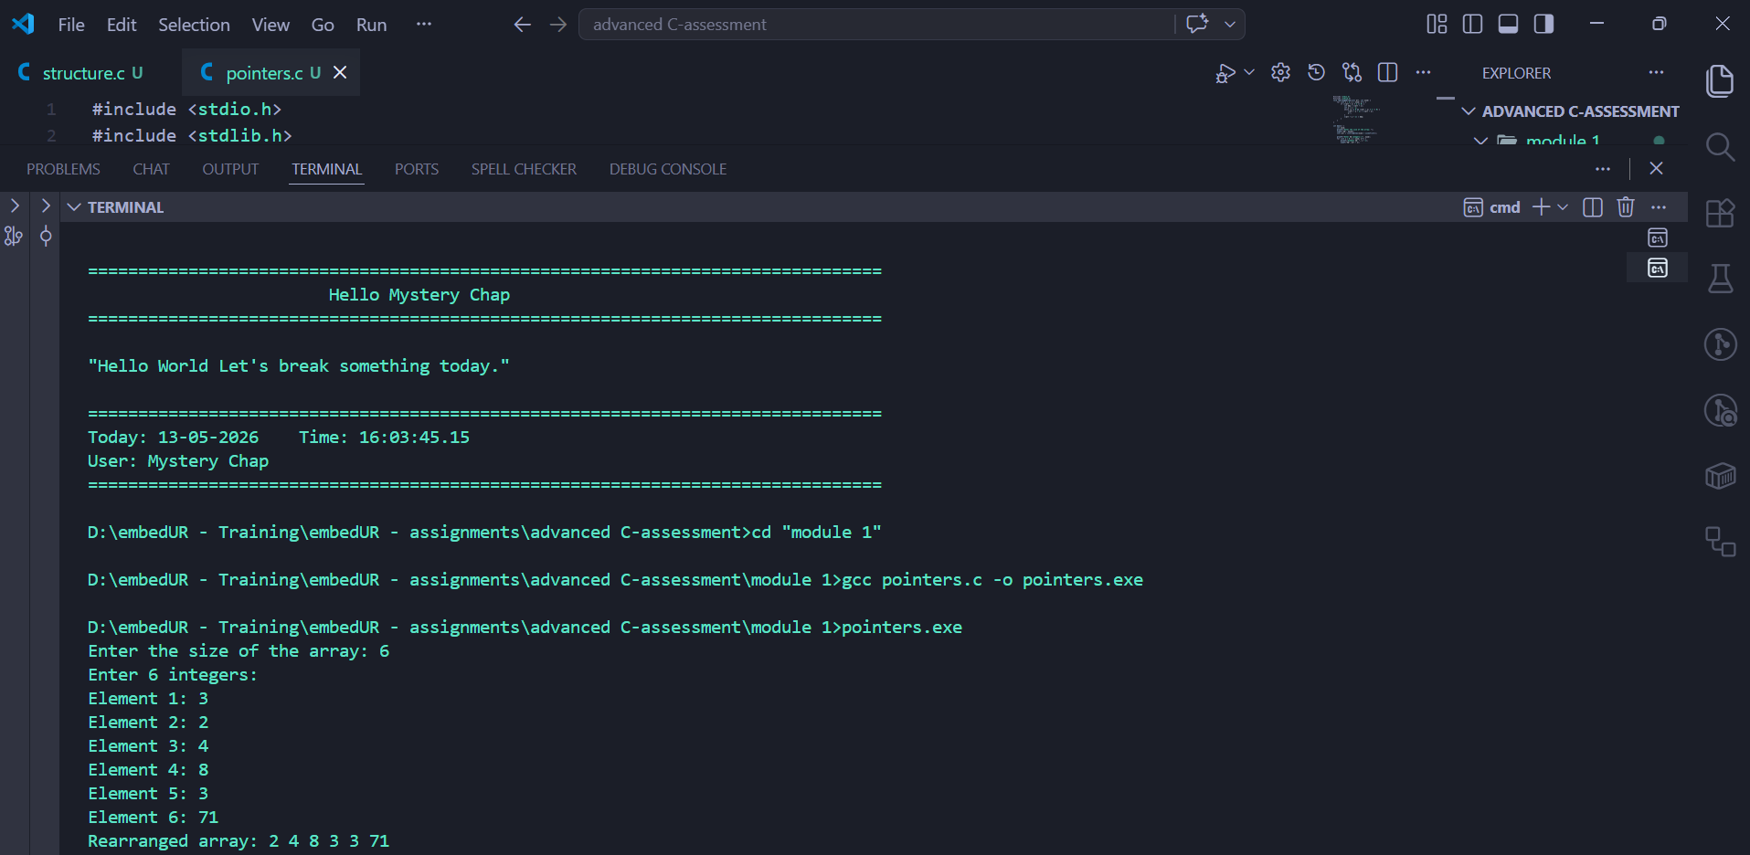

Topic 3: Arrays
You are given a 2D matrix of size n x n where each row and each column is sorted in increasing order. Write a C function to determine whether the given key exists in the matrix using the most efficient approach.
Code:
#include <stdio.h>
#include <stdlib.h>

int keyExistInMatrix(int** matrix, int rows, int cols, int key) {
int x = 0, y = cols - 1;
while (x < rows && y >= 0) {
if (matrix[x][y] == key)
return 1;
else if (matrix[x][y] > key)
y--;
else
x++;
}
return 0;
}

int main() {
int rows, cols, key;
printf("Enter the number of rows and columns: ");
scanf("%d %d", &rows, &cols);
int** matrix = (int**)malloc(rows * sizeof(int*));
for (int i = 0; i < rows; i++) {
matrix[i] = (int*)malloc(cols * sizeof(int));
printf("Enter row %d: ", i + 1);
for (int j = 0; j < cols; j++) {
scanf("%d", &matrix[i][j]);
}
}
printf("Enter the element to search: ");
scanf("%d", &key);

if (keyExistInMatrix(matrix, rows, cols, key))
printf("Element exists in the matrix.\n");
else
printf("Element does not exist in the matrix.\n");

for (int i = 0; i < rows; i++)
free(matrix[i]);

free(matrix);
return 0;
}

Output:
